Concerning Biases About Socio-economic Implications of Artificial Intelligence

Jože Kranjc
Višja strokovna šola Brežice

Bojan Sešel
Višja strokovna šola Celje

Several fearful predictions regarding socio-economic impact of emerging Artificial Intelligence (AI) may have been noticed recently in mainstream media. Explicit statements that robots and/or other automation will take our jobs are targeting primarily our emotions and consequently our future decisions. The aim of this paper is to tackle the deeper intentions behind publicly stated AI pros and cons. Not surprisingly that there is no prevalent expert stance about the future implications due to still unresolved gap between technological determinism and social construction view. To find meaningful correlation between recently achieved technological level and its most interesting implications we applied Spearman's rank correlation method upon relevant wide available secondary data. We found out that selective excerpts and/or biased interpretations of scientific papers in mass media may led to misinformation. Human biases have been so far even learned by machines becoming racist and sexist.

Keywords: artificial intelligence, jobs takeover, technology impact, rank correlation

Introduction

»Artificial Intelligence (or AI) is likely to do with white collar jobs like how machines have been doing blue collar work«. Shall we be excited or worried? Searching for advice on web it doesn’t take long to come near conclusion that we are all approaching a jobless society. Taking some more time it turned out that beside hyped robot narrative there are so many contradictory views that it is hard to obtain a definite opinion about the real state of affairs. Seeking for reasonable explanation it came out that the notion of bias shall be addressed at first.

Aiming that, this paper will review relevant prominent opinions and most cited research work. Afterwards some common topics regarding bias and future prediction we will be tackled. Our goal is to find out which implications of AI are most controversial. For some of most concerning issues we shall experimentally examine relations to assess which biases might be present. Disparate predictions can not be accurate, though the aggregate distribution can still be informative. Expert predictions contradict each other considerably, and are indistinguishable from non-expert forecasts and past failed predictions [1]. Experts are poor predictors in many areas, and AI looks likely to be one of them. Many believe that AI will be serious threat to the humanity, other are convinced that machines will help and improve us.
Futurist Ray Kurzweil predicted that the singularity, when artificial intelligence exceeds human's intellectual capacity, will arrive around 2045 [2]. Unlike many famous experts, he isn’t worried about artificial intelligence. Renown scientist Stephen Hawking said that super intelligent AI will be extremely good at achieving its goals, and if those goals aren't aligned with ours, we're in trouble. Some form of world government could regulate AI, but would itself create more problems. Tesla CEO E. Musk believes that AI could make humans irrelevant. In order to continue serving a purpose, humans will have to merge with machines by 2030s. “There will certainly be a lot of job disruption because what’s going to happen is that robots will be able to do everything better than us. Having a manually operated vehicle would be as outdated as traveling by horse” he stated to RT News [3]. AI will cause social conflicts over the next three decades told Jack Ma, the billionaire chairman and founder of Alibaba. He referenced a 2016 Forrester study suggesting that automation will eliminate 6% jobs in US till 2021.

Andrew McAfee exposed that as we’re coming out of successive recessions the growth comes back also output comes back, but the employment does not return the same way. Brynjolfsson and McAfee are ultimately optimistic about the jobs that will be created. Many jobs will be for sure swept away by innovations like the driverless car and 3D printers, but with the right approach, such advances can bring forth better future. Interventions will be inevitable to prevent from the polarization of the labor market and surging income inequality. Susskinds [4] wrote about the end of the professions as we know them. They argue that we will neither need nor want doctors, teachers, accountants, architects, the clergy, consultants or lawyers to work in the way they did in the twentieth century. Hence massive job loss can be expected also at the higher professional level. The same will ultimately democratize expertise and empower people. Jeremy Rifkin points out that people that lose a low-skilled job often lose the only job they are able to do. They are on the lowest rung of ability and learning. However, the new job that arises from the machine that ‘steals’ their job often requires computer programming skills, if not a college degree in computer science. Even if surplus work force could be upskilled or retrained into STEM field so will do the same other countries where workers can be paid less. Rifkin explains paradox of capitalism. In a traditional market, sellers are always looking for new technologies to increase their productivity. With reduced marginal costs they can offer cheaper products and beat out their competitors. So far business people simply never expected that there would be technology advancement so powerful that it might reduce cost margins near to zero. The emerging Internet of Things is speeding us to an era of nearly free goods and services, causing the rise of a global Collaborative Commons and the eclipse of capitalism

In 2011, McKinsey calculated that “the Internet created 2.6 jobs for each one lost to technology-related efficiencies.” McKinsey also showed that currently demonstrated technologies could automate 45 percent of the activities people are paid to perform and that about 60 percent of all occupations could see 30 percent or more of their constituent activities automated with technologies available today. AI expert Andrew Ng is greatly concerned, about the speed of machines driven by AI to continually erode what many people have to offer as labor, and about the inadequate education system to teach people new skills. Recent and forecasted growth in college enrollments and the number of graduates exceeds the actual or projected growth in high-skilled jobs. That mostly explains the development of the underemployment problem and its probable worsening in advance.

Methods and data

Purpose of technological forecasting [5] is to help evaluate the probability and significance of various possible future developments so that better decisions can me made. The most effective techniques are based on careful analyses of past experience combined with the insights of competent and imaginative people. Essential are observation and measurement of underlying data, trends, and interactions. Several recent studies have suggested that clearly perceived demand—not excess technological capacity—tends to be the primary force stimulating technological change. Demographic and sociological analyses can often help to outline the nature and extent of future technological needs. Precision is not a realistic demand at predictions, nor is it necessary in order to justify incurred costs. To be worthwhile, forecasts must simply allow better outcomes than could be accomplished without them. Typical methods and approaches of futures studies are preeminently trend analysis, cyclical pattern analysis, environmental scanning, scenario planning, visioning, Delphi and technological forecasting [6]. Most futurists would agree that multiple methods must be used to address futures problems. There is also rising consensus about how participatory research should be. Stakeholders and decision-makers must be involved directly in the process of developing forecasts or creating scenarios. Despite tending toward objectivity, most futures methods still rely heavily on human judgment. Questions and ideas producing different judgments and revealing consistencies and inconsistencies among and within competing views can be powerful tools to diminish subjective biases.

Biases which are likely to be present at AI discourse.
- Economic bias: present at AI vendors’, financiers’, commerce, labor and end users.
- Political bias: potential military use and other power gathering implementations.
- Ideological bias: notion of predominant intelligence contradicts liberal equity principle. Liberals are disproportionately represented in social psychology with e.g. eight democrats vs. a republican in social sciences.
- Status quo bias: unjust beneficiaries of existing system will resist to changes.
Cognitive bias
- Confirmation bias: tendency to search for, interpret, favor, and recall information in a way that confirms one's preexisting beliefs (technophilic either technophobic).
- Framing bias: packaging of an element of content in such a way as to encourage certain interpretations and to discourage others (suggesting definite point of view).
- Social comparison bias: people who have high standing on a relevant dimension protect their social comparison context somehow (AI as new wise man competitor).
- Selection bias: non-random sample of population (e.g. excessively exposing population segments on which AI will have extreme effects).
Research bias
- Publication bias: studies with positive results are more likely to be accepted for publication than studies with negative results.
- Citation bias: researchers are more likely to cite positive study results than negative.
- Bandwagon bias: findings that conform to other beliefs and hypotheses are more likely to be accepted.
- Funding bias: study conclusions are biased in favor of the sponsors’ views.

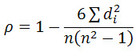
Implementing ‘rocket science’ methods upon vague data in social sciences can hardly lead to anything more than the illusion of research rigorousness. With our heuristic approach we shall at least coarsely quantify concerning relations which are typically subjected to qualitative judgments. To determine representative rank from several others, the harmonic mean rank method will be used (1). Among several rank correlation methods, namely Pearson’s r, Kendall's tau and Spearman’s rho (2) we picked the latest.
$H=n/{\sum_{i=1}^{n}{x_{i}}}$
(1) (2)

Results

Trying to clarify relationship between our present general well-being and technology we examined the topic indicative country rankings. There are several renowned rank lists, namely Legatum Prosperity Index, OECD Better Life, Happiness Index, Best Countries. There is no evidence which of them is most representative. The latest ranking with worst inter-correlation was not taken into account at composing overall rank list (‘well’ in Table 1) which was then found to highly positive correlates to each of its constituents.

The same method we applied to popular top rank lists of countries with “most advanced technology” to obtain ‘tech’ representative rank list. Only 11 countries appear on both composed (top 20) ranks what makes deficient space for valid conclusions. Therefore we tried with OECD Main Science and Technology Indicators. Spearman’s correlation coefficient between composite well-being rank list and country rankings of Gross Expenditure R&D (GERD) as a percentage of GDP, (either per capita) was found to be close to zero. Technology Achievement Index (TAI) is used by the UNDP (United Nations Development Programme) to measure how well a country is creating and diffusing technology and building a human skill base, reflecting capacity to participate in the technological innovations. Our result demonstrated inherent shortcoming of top rank correlation methods. Two correlation lists had 75% countries in common. Taking complete TAI top list as a reference we got low correlation coefficient of 0,3. Having ‘well-being’ as a reference Spearman’s rho turns out to be only 0,02.

Table 1: Country rank* lists in consideration
rng | prosp | life+ | hapy | well** | tech** | tai | rd/gdp | rd/1 | gini
1 | NZL | NOR | NOR | NOR | JPN | FIN | ISR | CHE | FIN
2 | NOR | AUS | DNK | NZL | USA | USA | KOR | SGP | SVK
3 | FIN | DNK | ICL | DNK | FIN | SWE | JPN | USA | SVN
4 | CHE | CHE | CHE | CHE | SGR | JPN | SWE | SWE | SWE
5 | CAN | CAN | FIN | FIN | KOR | KOR | AUT | ISR | CZR
6 | AUS | SWE | NLD | CAN | IND | NLD | DNK | AUT | BEL
7 | NLD | NZL | CAN | ICL | DEU | UKN | FIN | KOR | NOR
8 | SWE | FIN | NZL | NLD | CHN | SGR | DEU | DNK | DEU
9 | DNK | USA | AUS | SWE | CAN | CAN | CHE | DEU | ICL
10 | UKN | IRL | SWE | AUS | UKN | AUS | USA | JPN | HUN
11 | DEU | NLD | ISR | USA | SWE | DEU | BEL | LUX | DNK
12 | LUX | DEU | AUT | DEU | ISR | NOR | FRA | FIN | FRA
13 | IRL | LUX | USA | LUX | NLD | IRL | SVN | NOR | AUT
14 | ICL | BEL | IRL | UKN | RUS | BEL | ICL | BEL | CHE
15 | AUT | AUT | DEU | AUT | NOR | NZL | AUS | ICL | KOR
16 | BEL | UKN | BEL | IRL | CHE | AUT | CHN | NLD | NLD
17 | USA | IRL | LUX | BEL | AUS | FRA | NLD | AUS | AUS
18 | FRA | FRA | UKN | FRA | PHI | ISR | SGP | FRA | LUX
19 | SGP | ESP | CHL | ESP | EST | ESP | CZR | IRL | POL
20 | SVN | SVN | UAE | SVN | FRA | ITA | NOR | CAN | IRL
21 | ESP | CZE | BRA | SGP | HKG | CZH | UKN | UKN | ITA
 |  |  |  |  |  | HUN | CAN | SVN | CRO
*) … OECD country codes |  |  |  |  |  | SVN | IRL | CZR | CAN
**) … composite rank |  |  |  |  |  | HKG | EST | ITA | UKN

Prediction that AI is going to make income inequality even worse challenged us to inspect the claim. We found extrapolation method as convenient one. Therefore the present relationship between equality and technology level must be quantified. For the sake we implemented renowned GINI index (World Bank 2014 estimate) vis-à-vis above mentioned TAI. High ‘World Bank GINI’ rank list correlation to CIA GINI coefficients indicates sufficient reliability of implemented data source. The result showed us low negative correlation between technology achievements and income equality.

Regarding the hyped narrative about mass job disappearance we cross-examined several data sources to get quantitative impression of most daring futurist claims. We confronted Frey & Osborne’s ‘susceptibility of jobs to computerization’ ranking against ‘Occupations with the most job growth’ rank list from Bureau of Labor Statistics. Whether at all the most growing segment of predicted job openings is at highest danger, and how much comparing to the rest, can not be figured out from a commonly used scattering diagrams. Rearranging and recalculating data, two intervals stand out from rendered graph shown at Exhibit 1. We can see that the most growing jobs have roughly twice the probability to be overtaken by AI.

Exhibit 1: Most growing jobs are most likely to be lost

The same approach was adopted to acquire insight into income prospects for the most growing jobs. From our quantifiable visualization (Exhibit 2) of source data there is evident that up to 70% of new job openings will be in the wage range below $35 000.

. Exhibit 2: Endangered jobs will not be financially attractive

Discussion

Our first, though unprogressive, conclusion was that income equality is slightly negative correlated with present level of technological development. The same goes for human well-being. Therefore it can be expected that less equality due to more technology will not worsen our overall prosperity. We found no evidence that the direct relation between technology and well-being has been negatively correlated so far (Exhibit 3). All together suggests that substantial ideological bias disturbs discourse.

All those who are currently doing well can not escape the status quo bias. Many are frightened by the shrinking of the middle class and declining share of better paid jobs. Latest developments, illustrated in Exhibit 4, tend toward stagnation of demand for higher paid skills. But the picture depends on observer’s standpoint or rather his selection bias. Despite technology advancement, the male workers in US have experienced significant real earnings declines over the last four decades [6]. But globally the most of population has benefited during that time. Branko Milanović, the lead economist in the World Bank's research department, implied this idea within famous ‘elephant curve’. The threshold income to become either to stay in global 1% elite group is lower than someone might think - just $34,000 per person.

Well-being
TAI
(UN)
GINIW-B
GINI
CIA
OECD
R&D
Techno top
+L
+H
0
+L
-L
+M
-L
+H
+L
Correlations: High, Mid, Low, + positive, - negative

Exhibit 3: Rank correlations among selected implications

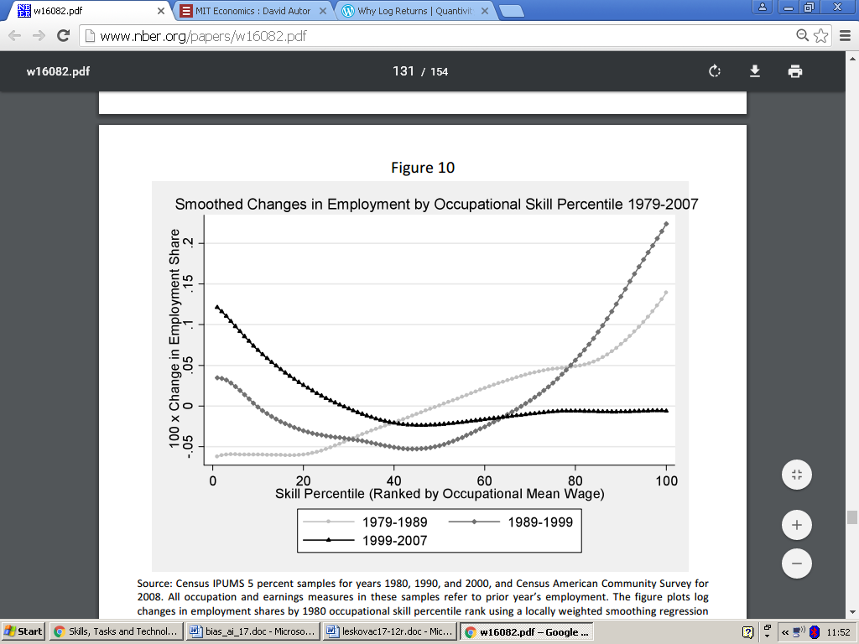

.

Exhibit 4: Stagnation of demand for better paid skills [6] p. 131
Conclusion

As stated by Schumpeter [7],” it was not the lack of inventive ideas that set the boundaries for economic development, but rather powerful social and economic interests promoting the technological status quo”. People will resist new technologies anytime they perceive their expected earnings will be threatened. Centuries ago emerging manufacturing technologies made at that time high skills of artisans obsolete. Deskilled batch production was based on simplified tasks. Work that had previously been performed by artisans was then decomposed into smaller highly specialized sequences, requiring less skill, but more workers to perform. Technological advancement gains were distributed in a way that gradually benefited a growing share of the labor force. At first, industry assembly lines were specifically designed for machinery to be operated by unskilled workers. Electrification contributed to a growing share of relatively skilled blue-collar labor, but also increased the demand for white-collar workers who tended to have higher educational attainment. So far, technology has vastly shifted the structure of employment with two competing effects. As technology substitutes for labor, there is a destruction effect, requiring workers to reallocate their labor supply. Consequently more companies enter industries where productivity is relatively high what partly compensates initial job losses. In 2010s the demand for skill declined, even as the supply of workers with higher education has continued to grow. High-skilled workers have moved down the occupational ladder, taking on jobs traditionally performed by low-skilled workers. Therefore a question arises about the ability of human labor to win the race against technology by means of education. We believe that, more than providing new answers to subject discourse, the exposure of some herein implied unpleasant questions will be effective.

Literature
[1] S. Armstrong and K. Sotala.. “How We’re Predicting AI—or Failing To.” In Beyond AI: Artificial Dreams, edited by Jan Romportl, University of West Bohemia, Pilsen, 2012, p 52–75.
[2] Hiroyuki Nitto et al., Social Acceptance and Impact of Robots and AI, NRI Papers, Nomura Research Institute, Tokyo 2017.
[3] ‘Fundamental risk to civilization’, RT News, Published time: 16 Jul, 2017 11:43 https://www.rt.com/viral/396468-spacex-musk-artificial-intelligence-fears/
[4] R. Susskind and D. Susskind, The Future of the Professions: How technology will transform the work of human experts, Oxford University Press, Oxford 2015.
(5) J. B. Quinn, Technological Forecasting, Harvard Business review, Harvard Business Publishing, March Issue, Brighton, MA 1967.
[6] D. Acemoglu, and D. Autor, Skills, tasks and technologies: Implications for employment and earnings, Working Paper 16082, National Bureau of Economic Research, Cambridge, MA 2010, p. 131.
[7] C. B. Frey and M. A. Osborne, The Future Of Employment: How Susceptible Are Jobs To Computerisation? University of Oxford, Oxford 2013.
O pristranostima vezanim za socio-ekonomske implikacije veštačke inteligencije

Jože Kranjc
Višja strokovna šola Brežice

Bojan Sešel
Višja strokovna šola Celje

Nekoliko uznemirujućih predviđanja se je moglo nedavno primetiti u mnogim masovnim medijima, a u vezi sa socio-ekonomskim uticajima novo nastale veštačke inteligencije (VI). Eksplicitni navodi da će roboti, odnosno druga automatizacija, preuzeti naša radna mesta, ciljaju prvenstveno na naše emocije, a samim tim i na naše buduće odluke. Cilj ovog rada je pronalaženje mogućih pristranih interesa u pozadini, pozitivno odnosno negativno, izraženih stavova prema VI. Prisutna razmimoilaženja u stručnim krugovima nisu nikakvo iznenađenje, jer ih uslovljavaju antagonizmi, koji postoje između principa tehnološkog determinizma i socijalne konstrukcije. Da bi smo pronašli za naše namere smisaonu korelaciju između postignutih tehnoloških nivoa i njihovih najzanimljivijih društvenih uticaja, primenili smo metodu Spearmanove korelacije na relevantnim rang listama največih svetskih ekonomija. U vezi medijskog prenošenja rezultata stručnih razmatranja VI, nije bilo teško ustanoviti, da su več poluistine dovoljne za iskrivljavanje izvornih teza. Praksa je pokazala da se putem mašinskog učenja prenose i ljudske predrasude.

Ključne reči: veštačka inteligencija, preuzimanje radih mesta, uticaj tehnologije, korelacija rang lista.

